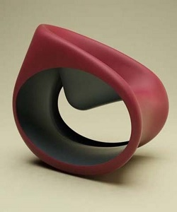

Durian rocking chair

$71.09

Availability: In stock

Description

Modern bangle shaped maroon rocking chair. Easy does it. Solid rubber and classic are well matched in this walnut finish sofa. Durian bringing the best of products of sofa at the best prices!